Having Lili on board is just fantastic, we had a great few days, just gently sailing around in mostly very little wind. It is a wonder we actually made it to anywhere.
The second day was quite eventful, we had barely left Riva di Traiano when the roller furler gave up the ghost. It just would not do its thing. So we went the old fashion way and just kept a close eye on the wind just in case we had to drop it as we could not make it smaller. Of course that afternoon we had the most wind of the whole trip, up to 18 knots...
We could not get into the Port Ercole harbour in the middle of the village which we had earmarked as the prettiest harbour, surrounded by hills and numerous hill forts dotted on the tops. We had to moor up in the adjacent Marina Cala di Galera, which was a good 40mn walk from the village. While Lili went for a swim to the very close beach, we were on roller furler repair duty. It did not take long, the cable had snapped and all it needed was to be reattached to the drum, which Ian duly did. It was just perfect apart from the fact that the sail was inside out...but hey it did work. We were rewarded by a nice long walk to the village and a pizza on the sea front, watching the world go by.
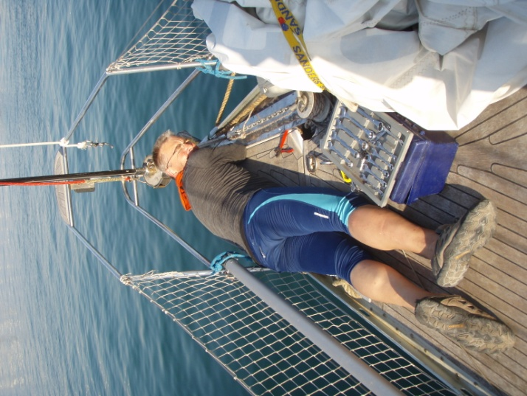
We woke up next morning to the most eerie sight. I was early, wanting to have a swim before we left but all around us had disappeared. No sea, no hills, no forts and barely any marina was visible, a thick fog was surrounding us. The world was just muffled in cotton wool and it was quite chilly. Swimming was out, we had a leisurely breakfast instead and tried to plot where we were going for the next leg which involved Lili grilling the locals to figure out where was the best island to visit and calling to try to make reservation for an anchorage....with no luck at all. She could either not reach anyone of the places she tried were full up. It did not take long for the sun to burn the fog out and by mid morning we were able to depart in no wind at all. We had settled to go to Isola del Giglio, which looked like there was plenty of good places to anchor and surelygiven its size it could not possibly be full.

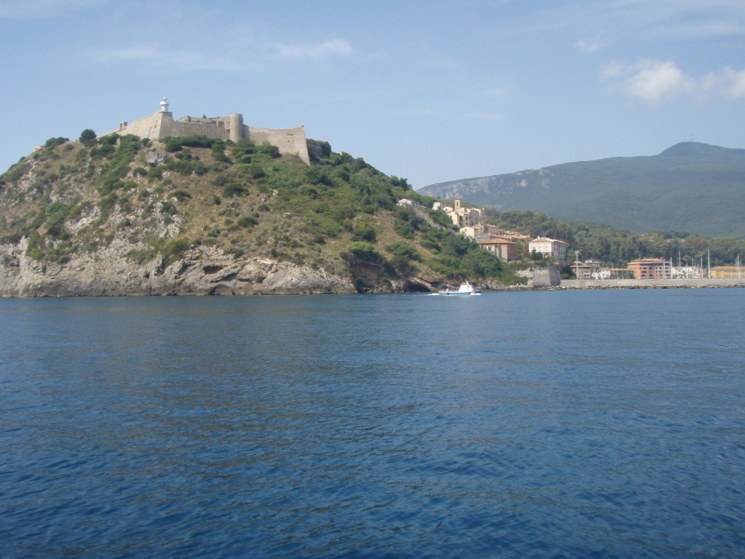

We had to motor all the way to our next destination. We really wanted to go and anchor in a quiet bay somewhere out of the way. Marinas and their facilities are good but it’s a bit like a caravan park, and we were ready for a bit of “camping sauvage”. We had selected Isola del Giglio ealier in the day but given the number of motor boats going extremely fast obviously heading in that direction (rant of the day), we opted to stop for the night in Cala Schiavona on isola Giannutri which given that it was very small and with no facilities, we thought we stood a chance to find space. We arrived early afternoon and sure enough there was plenty room for us. Our first anchorage was a bit nerve wracking, motoring straight towards the rocks which you could see distinctly in the clear sea, and still 15 metres under us! I swear we got to within 5 meters of the shore before Ian dropped the anchor. Once secure, we got in holiday mode and spend a good part of the afternoon swimming and having snozettes in the sun...well, some of us did, Lili was curtain twitching and making up stories about our neighbours, which was quite entertaining. We all got going at being nosy when one of the power boat lost his anchor and tried desperately to retrieve it. He was extremely lucky that one of the boats anchored had a diver with all his gear on board, still it took a good couple of hour to retrieve it. We had a great evening once all the day trippers had moved on,and watching the moon and the stars in the quiet of the bay was just bliss.
The return journey to Riva Traiano was fairly uneventful, a bit of wind on the way but still not much, until the lazy jack snapped, much to the delight of Lili, when climbing up the mast was mentioned. We duly put her up, shrieks of excitement all the way and she successfully fixed the issue.
Our last day at sea wit Lili was blessed with sighting of dolphins, we watched them for a while hoping they would come closer but they disappeared on the horizon.
Back in home port we celebrated our return by taking Lili to our favourite little restaurant. Actually we don’t have much choice, there are only 3 walking distance from the yard. Again we were extremely lucky, “ Fumicino got talent” was taking place and all the families of the performers on stage had taken over the whole of the restaurant. They managed to find a small table for us and we had a brilliant evening. We could not have timed it better, fitting end to a great week with Lili.

